Agroecological Importance of Smooth Brome in Managing Wheat Stem Sawfly (Hymenoptera: Cephidae) via Its Associated Braconid Parasitoids

2024-06-11

This document can be downloaded as either a .docx or .pdf document. Please be aware that conversion may cause the formatting to be altered.

Download .docx

Download .pdf

## Abstract

Wheat stem sawfly, *Cephus cinctus* Norton (WSS), causes significant damage in cereal crops throughout the Northern Great Plains of North America. *Bracon cephi* and *B. lissogaster* are native WSS parasitoids important in managing WSS outbreaks and damage. Smooth Bromegrass (*Bromus inermis*) grass has been found to be an effective parasitoid sink, and potential trap crop, when grown in areas surrounding wheat fields in Montana. As climate changes continue to alter central and northern Montana, WSS will continue to cause immense damage to dry-land cereal crop yields. We analyzed both local temperature and precipitation trends at our sample sites, and found statistically significant increases in temperature and decreases in precipitation over the past fifty years. Our study observes the utilization of smooth brome in providing year-over-year host refuge for Bracon spp parasitoids. We measured the WSS larval infestation and survival rate within controlled smooth brome plots, observing a maximum infestation of 66.5% and a maximum end-of-year survival of 5.7%. We also collected stems from sites in central and northern Montana where we measured the WSS infestation and parasitoid prevalence within cultivated wheat and adjacent smooth brome. Montana fields sites showed high levels of *C. cinctus* infestation within both *B. inermis* and adjacent wheat crop in Big Sandy (64.5% *B. inermis*, 65.7% adjacent wheat) and Moccasin (50.6%, 38.6%). We observed high year-end WSS larval mortality measured as stem cutting of infested stems with *B. inermis* when compared to adjacent wheat in Big Sandy (2.9% *B. inermis*, 46.5% adjacent wheat) and Moccasin (6.4%, 49.4%). Infested stems exhibited parasitism in both Big Sandy (7.11% *B. inermis*, 8.6% adjacent wheat) and Moccasin (6.11%, 2.09%). This research underlines the importance of providing a sustainable ecological buffer for WSS parasitoids as climate conditions continue to change.

## Introduction

Ecologists and farmers frequently hold divergent views regarding the importance of natural habitats within agricultural landscapes, a distinction often overlooked in ecological and conservation discourse (Tscharntke et al. 2016). While ecologists recognize the role of natural habitats such as field border vegetation in supporting biodiversity and providing potential ecosystem services like biological pest control, many farmers perceive these semi-arid habitat remnants as occupying valuable cropland or even as sources of pests. As such, documenting how pest and natural enemy populations interact with agricultural landscapes alongside semi-natural habitat buffers on the crop periphery is important in determining the degree of the services or disservices provided.

Numerous polyphagous insect herbivores and their natural enemies rely on a variety of resources found across diverse habitat types within their environment. Depending upon the quality of the resource, different habitat types can serve as sources for increased pest or natural enemy populations. Similarly, these habitat types can serve as sinks that decrease populations (Kennedy and Storer 2000). Altering the presence of these resources can have impacts on pest or natural enemy populations and can alter the ecology between the examined species. For example, diversifying the edge cropping of organic *Brassica* using fava beans, fennel, and marigolds results in a diversity in beneficial arthropod communities that help reduce phytophagous herbivory (Morais et al. 2023).

Understanding the ways in which landscape habitat diversity impacts the ecological relationship between pest and enemy is crucial for effectively managing pest species in large scale cropping systems. Similarly, understanding how herbivore plant-hosts act as reservoirs for pests or beneficial natural enemies can potentially play a role in stabilizing year-over-year agricultural impact from these pests (Cano et al. 2022).

The wheat stem sawfly (WSS), Hymenoptera *Cephus cinctus* Norton, is a grass-mining sawfly native to North America [Criddle (1922); Ainslie1929; Wallace and McNeal (1966); Lesieur et al. (2016)]. Originally adept at utilizing wild grass hosts, the species became a major pest to cultivated cereals as this resource became more prevalent following European settlement, becoming a notable pest of winter wheat in 1990 in Montana (Morrill and Kushnak 1996), and more recently in Colorado (Cockrell et al. 2021). Climate warming has the potential to further expand the range of this pest both northward and southward (Olfert et al. 2019, Weaver 2023). Adult female WSS use their saw-like ovipositor to lay their eggs in the lumen of stems, where the eggs hatch, leading to larval feeding of parenchyma tissue [Roemhild1954; Holmes and Farstad (1956)]. Economic damage manifests in the form of both kernel weight reduction caused by tissue damage [Beres et al. (2011); Delaney2010] and stem toppling due to late-season larval girdling (Holmes and Peterson 1960, Nansen et al. 2005, McCullough et al. 2020).

Several parasitoid or predatory species attack *C. cinctus* within wild grass hosts Morrill et al. (2001), however, two species, *Bracon cephis* (Gahan) and *Bracon lissogaster* Muesebeck (Hymenoptera: Braconidae), have been observed targeting WSS within cultivated cereals (Nelson and Farstad 1953, Morrill et al. 1998, Runyon et al. 2001, Runyon 2001). These two host-specific ectoparasitoids are native to North America. Both parasitoids are bivoltine, with the first generation present in Montana from late-June to late-July, while the second generation is active from mid-July to September (Gahan 1918, Somsen and Luginbill 1956, Davis 2013). Adult female *B. cephi* and *B. lissogaster* inject a paralytic toxin into a *C. cinctus* larvae within the host stem, paralyzing the host larvae, and depositing from a single (*B. cephi*) to 1-3 (*B. lissogaster*) eggs. *B. cephi* and *B. lissogaster* have been shown to provide biological control via irreplaceable mortality of *C. cinctus* populations (Peterson et al. 2011, Buteler et al. 2015) and can significantly reduce *C. cinctus* damage and impact on crop yields (Buteler et al. 2008, Bekkerman and Weaver 2018, Adhikari et al. 2019, Rand et al. 2020). While *C. cinctus* has a wide range of viable host plants, including native and non-native grasses and cultivated row-crops such as wheat (*Triticum aestivum L.*) and barley (*Hordeum vulgare*) (Wallace and McNeal 1966, Cockrell et al. 2017, Achhami et al. 2020), infestation levels can vary widely across hosts. Previous research has shown preference for host plants with larger stem diameter (Ainslie 1920, Buteler et al. 2009, Bhandari 2020).

Recent research has shown natural non-cultivated grasses such as *Agropyron cristatum*, *Bromus techtorum*, *Bromus inermis*, *Elymus trachycaulus*, and *Thinopyrum intermedium* host *C. cinctus* and most also host Bracon spp. parasitoids quite well (Perez-Mendoza and Weaver 2006, Peirce et al. 2021, Rand et al. 2024). We find investigating *B. inermis* holds the most potential, as it has been shown to be a quality initially-accepted host for *C. cinctus* oviposition while also leading to high larval mortality later on (Seamans 1928, Farstad and Jacobson 1945). However, there is a lack of detailed relating to the total infestation, cutting, and parasitism within *B. inermis* at multiple time points throughout the growing season. Quantitative assessment of potential ‘reservoir’ characteristics and local spatial information could prove useful in fully understanding the ecological impacts of maintaining *B. inermis* along roadways and within coulees.

Smooth brome (*Bromus inermis* Leyss) is a Eurasian cool-season rhizomatous grass introduced to the United States in 1884 (Salesman and Thomsen 2011).*B. inermis* was originally thought of as potentially useful as a trap crop in order to combat the growing WSS problem with cultural control practices (Criddle 1922, Seamans 1928, Farstad and Jacobson 1945, Beres et al. 2011). Due to its low agricultural value, and propensity to form monocultures and out compete many native grasses, *B. inermis* is categorized as invasive in some habitats (Carlson and Newell 1985, Willson and Stubbendieck 2000, Dillemuth et al. 2008). However, *B. inermis* still holds considerable ecological and potential economic value due to its late senescence and WSS antibiosis properties (Otfinowski et al. 2006, Rand et al. 2024).

Montana’s golden triangle, an area of central and northern Montana with intense cereal grain production, is prone to drought and burning via wildfire (Wilson 1923, Adhikari et al. 2019). As both *C. cinctus* and its host-specific parasitoids are relatively restricted in their annual mobility (Weaver et al. 2005), environmental extremes can have broad impacts on both local pest and natural enemy populations. As with many predator-prey interactions, the *C. cinctus* and parasitoid populations fluctuate, with crashes and spikes experienced in close succession and through ineteraction with drought (Holmes et al. 1963, Holmes 1982). Similar examples of these classical population dynamics patterns can be found in wolves and moose on Isle Royale (Peterson 1999), and Coccinellidae and aphids (Evans 1999), among others.

We examined historical weather data from two field locations (10 sites overall) in central and northern Montana. We used this data to understand how changes in global climate trends may be impacting *C. cinctus*, *B. cephi* and *B. lissogaster* interact with *B. inermis* populations. In addition we analyzed normalized difference vegetative index (NDVI) at our field sites to understand how *B. inermis* senescence patterns compare to adjacent cultivated wheat fields.

In this study, we explored the ecological patterns between Montana populations of *C. cinctus* and its associated braconid parasitoids in relation to *B. inermis* host sites. Our goal, was 1) to understand the degree to which *C. cinctus* infested *B. inermis* stems in relation to neighboring cereal crops, and 2) the way in which braconid parasitoids utilized WSS hosts available within *B. inermis* stems. To do so, we conducted two separate studies. In our first study, we conducted controlled *C. cinctus* infestation of *B. inermis* to understand the relative infestation and cutting rate of *C. cinctus* within the *B. inermis* stems in the absence of parasitoids. The second study examined rates of cutting and parasitism in wheat crops and their surroundings at field sites in central and northern Montana.

Using these studies, we addressed three questions, 1) what is the total *C. cinctus*-caused stem cutting heading into overwinter - and thus the source rate, of the subsequent *C. cinctus* population in *B. inermis*? 2) can *C. cinctus* larvae within *B. inermis* serve as critical second generation hosts for *B. cephi* and *B. lissogaster*? and 3) how do annual *C. cinctus* and parasitoid populations in *B. inermis* compare with those in the adjacent cultivated wheat fields?

## Materials and Methods

### Controlled *C. cinctus* infestation of *B. inermis*

*Insects and Cages.* Assessment of *C. cinctus* infestation and mortality within *B. inermis* were assessed using a 34 x 60 ft plot at the Arthur H. Post Agronomy Farm (43°38’19.39”N, 116°14’28.86”W), an experimental farm of Montana State University in Bozeman, MT. There is a negligible population of *C. cinctus* and associated parasitoids at this location. Experimental cages were built using 1-inch PVC piping with the netting made using 530 $μ$ Amber Lumite Screen (BioQuip $​^{®}$ Products, LLC). Twelve cages were built to dimensions of 6ft x 3ft x 3ft (L x W x H) with cage locations selected randomly based on the space available within the plot and arranged in sets of three.

Wheat stem stubble was collected in Three Forks, MT, USA (43°38’19.39”N, 116°14’28.86”W) from fields that experienced high levels of *C. cinctus* infestation and cutting the year prior, as previously described (Hager et al. 2024). Cut stubble, which contained *C. cinctus* larvae in diapause, were kept refrigerated between -2°C and 3°C for >100 days as required to complete obligatory larval diapause. As needed, stubs were removed from refrigeration and kept at 22-27°C for 4-5 weeks inside of 100 oz GladWare® storage containers (Glad®, Oakland, California USA). Once *B. inermis* stems reached six inches tall, stub containers with emerging sawflies were added to cages to mimic sawfly infestation pressure. Sawfly quantity treatments were as follows: high (600 stubs), low (200 stubs), and control (0 stubs).

*Data Collection.* In late August, *B. inermis* stems were collected from each cage. Each stem was dissected using X-Acto® knives to collect data on infestation, dead larvae and live larvae, as well as very rare parasitism events, for each internode.

### Montana Field Survey

*Weather data and NDVI* Field sites were chosen across two counties, Choteau and Judith Basin, within the ‘Golden Triangle’ of Montana, United States fig. 1, areas that consistently experience high *C. cinctus* pressure. We assessed the medium- and long-term temperature and precipitation trends of our field sites using weather data from the National Oceanic and Atmospheric Administration (NOAA, Silver Spring, MA, USA). Data for each field site was averaged from three of the closest weather stations to that location.

To better understand how precipitation patterns vary throughout the growing season, we looked at local daily precipitation totals from weather stations at our sampling sites in Big Sandy and Moccasin, MT. Data was pulled online from historical WeatherUnderground weather station data (Company 2024). Precipitation readings were broken into two categories - dates before July 15 and after September 15, as well as between July 15 and September 15. These dates were chosen based on typical wheat harvest and historical periods of known *Bracon* spp activity. In the ‘Golden Triangle’, typical spring wheat harvest takes place in mid-July on average (Wilson 1923, Zhu and Burney 2021).

We used the normalized difference vegetation index (NDVI) to compare the relative greening throughout the growing season between wheat fields and adjacent *B. inermis* (fig. 2). NDVI is typically used to assess vegetation health and density, and is calculated from the visible and near-infrared light reflected by vegetation (Pettorelli et al. 2005). NDVI data measurements were directly downloaded using Google Earth Engine (Google Inc. 2023, Mountain View, CA, USA).

*Stem collection and processing.* We conducted a field survey to assess *C. cinctus* infestation, larval mortality, and *B. cephi* and *B. lissogaster* prevalence within *B. inermis* and adjacent wheat fields. Samples were collected from wheat fields and adjacent *B. inermis* in early July and late August in 2022, and 2023 from sites in Big Sandy and Moccasin MT, USA. Sampling sites were set up as 100 $m^{2}$ polygons along the edge of adjoining wheat fields. Four collection squares of 1ft x 1ft were randomly selected within each polygon during both collection events each year. All stems within each 1 x 1 ft square were collected using a shovel to remove both stem and root material. Wheat stems were collected at distances of 5 and 20 meters from the edge of the field. Samples were collected in 4 rows at 10 meters apart. 2 samples were collected in each row at distances of 5 and 20 meters. 1 ft samples were collected at each point.

Wheat and *B. inermis* stems were then returned to Montana State University, Bozeman, Montana and stored in a 10°C cold, humid storage until dissection. Stems were dissected in the same manner as samples from our controlled experiment. We recorded presence or absence of *C. cinctus* larval infestation, live eggs, dead eggs, dead larvae, live larvae and parasitism, in addition to stem cutting. Sawfly larvae were identified based on descriptions in Criddle (1915) and Wallace and McNeal (1996).

To better understand the densities of host *C. cinctus* and the *Bracon* spp. within the wheat and adjacent *B. inermis* at each sampling site, we converted our units to the ratio of parasitoids to surviving hosts stem per unit area. Densities of stems are different when considering semi-natural, long-standing stands of *B. inermis* and the adjacent cultivated wheat or barley.

### Statistical Analysis

All statistical analyses were done in R (Team 2024) using R Studio (version 4.3.2). Data was plotted using R package ‘ggplot’ (version 3.4.4) (Wickham 2016). We analyzed long- and short-term weather trends using linear modeling and the ‘lm’ command. Weather data was analyzed using either average yearly precipitation (inches) or average yearly temperature (°C) as the response variable and year as the predictor. Similar to our weather data analysis, NDVI data was linear modeled to discern differences in NDVI measurements over time.

We used generalized linear mixed models with binomial errors (logit link) fit using bound optimization by quadratic approximation, with a maximum of 200,000 iterations, were run in the *lme4* package in R (Bates et al. 2015) to examine the effects of location and year (fixed effects) on each of the three response variables: proportion of stems infested, proportion of stems cut, and proportion of stems parasitized by *Bracon* spp.

## Results

### Controlled *C. cinctus* Infestation of *B. inermis*

*C. cinctus* heavily infested stems of *B. inermis* in the controlled test conditions. Averaged across both years, we observed 66.5% of stems infested for high treatments and 47.3% of stems for low treatments. We found strong evidence suggesting that there was a significant difference between infestation at high and low treatment levels when holding year constant (*r = 0.83, P < 0.05*, Fig. 3).

Stem cutting by mature larvae, leading into winter, was observed at 5.7% for the high treatments and 3.9% for the low, showing strong evidence for a difference in cutting between high and low treatment groups (*r = 0.592, P < 0.05*). There was a dramatic decrease in survival observed from initial infestation to stem cutting.

*C. cinctus* infested stems often contained larvae burrowing through multiple nodes. In 2022, 64.3% of stems were observed to have at least 4 nodes burrowed through, or 5 internodes occupied. In 2023, 61.7% of stems had at least 4 nodes infested Fig. 4

### Montana Field Sites

#### Historical Weather Analysis & NDVI

In both Big Sandy and Moccasin, MT, we observed a decrease in average yearly precipitation and increase in average yearly temperature. We observed a significant linear relationship (*r = 0.1, P = 0.033, estimate = -0.058*) between average precipitation and year for both Big Sandy and Moccasin, Montana. For each location and one-year increase, we observed a 0.05 inch decrease in precipitation. (Fig. 5). Additionally, we observed a significant positive linear relationship (*r = 0.245, P < 0.05, estimate = 0.028*) between year and average yearly temperature for Moccasin and Big Sandy, MT. Thus, each year, the average daily temperature has increased by 0.03°C. (Fig. 6). Analyzing local, precipitation data over the past five years yielded information on how central and northern Montana experience relative dryness during the late-summer months. In Big Sandy, when controlling for year, we saw strong evidence of a significant difference (*p<0.05, F=2.067*, fig. 7) between daily rainfall in months prior July 15 and after September 15 compared to days within the July 15 to September 15 ‘late-summer’ period. Analysis of Moccain precipitation data revealed that there is little evidence (*p=0.08, F=1.535*) to suggest a difference between the two date categories.

We observed a notable difference in NDVI when comparing adjacent *B. inermis* and spring wheat. We saw a significant difference in the *B. inermis* post-July 15 NDVI (*0.846, P<0.05*) when compared to the post-July 15 NDVI of the adjacent wheat crop. The *B. inermis* NDVI remained relatively linear in it’s downslope compared to the wheat field (Fig. 7).

#### Field Site Samples

We quantified *C. cinctus* and *Bracon* spp. parasitoid presence in 6,148 wheat and grass stems across 10 research sites in 2022 and 2023. Initial infestation of *B. inermis* by *C. cinctus* varied between collection sites, with the greatest infestation taking place within our three Big Sandy, MT sampling sites (2023: 65.4%, 2022: 63.1%), while the lowest infestation observed was in Moccasin, MT (2023: 40.8%, 2022: 60.7%). Across all sites in Big Sandy and Moccasin, we observed an average infestation of 57.5% within *B. inermis* and 47.6% within the adjacent wheat. Cutting by *C. cintus* was observed at an average rate of 5.59% in *B. inermis* and 47.1% in the adjacent cultivated wheat (Fig. 8.

To generate a relative estimate of the number of available *C. cinctus* host larvae within *B. inermis* late in the growing season, we calculated the number of stems that contained at least four or more nodes with burrowing injury. In Big Sandy, 76.2% of collected stems in the fall exhibited at least 4 nodes of burrowing injury at our second sampling date. In Moccasin, the corresponding figure was 66.5% (Fig. 9).

We utilized the ratio of parasitized stems to cut stems to better understand the true impact of our *B. inermis* sink/source ecology. The largest ratio observed was in Big Sandy, MT in the fall of 2022, where we observed a ratio of 16 parasitoids to a single *C. cinctus*-cut stem. Thus, for every square meter of *B. inermis*, we would observe 16 stems that produced a parasitoid for every 1 stem that was likely to produce an adult *C. cinctus*. All other sample locations also showed positive ratios of parasitoids to cut stems (Fig. 10).

To understand the seasonal trends of *Bracon* spp use of potential *C. cinctus* hosts within *B. inermis*, we collected stem samples twice each growing season. We collected one pre-harvest, in July, and a second time in September, after all adult *Bracon* spp would be dead. We observed a significant difference (*df = 96, r = 0.304, p < 0.05*) between parasitoid presence in infested stems collected in Big Sandy and Moccasin, MT.

I want to drive home that stems with 3 + nodes infested likely had larave that were alive late into the summer. Compare the number of nodes infested in the summer to stems that have 3+ infested in the fall.

## Discussion

Assessment of *C. cicntus* infestation and larval mortality within *B. inermis* from out controlled infestation survey showed high infestation coupled with high larval mortality prior to overwintering diapause. Even in cases of high infestation (70%+), larval survival to cutting topped out around around 15%, pointing towards *B. inermis’* ability to serve as a quality sink for *C. cinctus* larvae. These results confirm the assertions by Criddle (1992) and Seamans (1928) that *B. inermis* can serve as a quality *C. cinctus* trap crop. In addition to high larval mortality, stem dissection exhibited high numbers of stems with over four internodes burrowed through by *C. cinctus* larvae. Larval movement through stems can be quick in the case of susceptible cultivated cereal grains (Criddle 1923). However, *B. inermis*, given it’s presumed antibiosis properties, leads to slower larval development and thus movement through the stem. We found several *B.inermis* stems with living larvae as late as late-September.

As the climate of central and northern Montana continues to change, wheat stem sawfly infestation will continue to impact cereal crop yields. Precipitation and temperature data from our sampling sites underscores the importance of continuing to monitor and conserve areas of semi-natural grassland. 50-year trends analyzed in this study show similar results to Pederson et al (2009) in which the dry-land agricultural environments found in central and northern Montana are likely to continue to become hotter and dryer on average. Over the past fifty years, precipitation in Big Sandy has decreased by an average of 0.05 inches per year. Given the trend continues, by 2050 the area could experience an inch less of rain per year.

Both average precipitation and average temperatures vary widely between years as the region goes through many droughts and periods of relative high rainfall (Pederson et al. 2009, Company 2024). Shown in our analysis of daily measurements over the past five years, precipitation significantly decreases during the period after wheat harvest, July 15 - September15, a period when second generation *Bracon* adults are searching for *C. cinctus* larval hosts. Mid-season senesence of many *C. cinctus* host plants can then leave *Bracon* parasitoids with little resources for

Prolonged drought, like seen in 2021 in Big Sandy, MT, can cause a dearth of green host plants in these semi-arid environments that can be problimatic for second generation adult parasitoids.

Given our analysis of NDVI at our sampling sites, it is clear that *B. inermis* is capable of continued late seasonal greening and may provide important resources for *Bracon* spp parasitoids in years of drought or crop failure. It is these buffer zones where parasitoids may be able to find *C. cinctus* larvae in numbers great enough to prevent the larger population crashes that can lead large localized increases in *C. cinctus* populations and damage (Holmes 1982).

Analysis of larval *C. cinctus* infestation of *B. inermis* and adjacent winter wheat reveal similar results to our controlled *B. inermis* infestation in Bozeman. We found *B. inermis* infestation to be similar to that of neighboring wheat fields, making it likely that *C. cinctus* pressures *B. inermis* similarly to cultivated wheat.

Still working on adding some citations and information discussing Rand & Peirce papers and how my findings are similar and different. I collected samples twice throughout the year so got a bigger picture of how parasitism changes for each generation. It is looking like parasitism in the fall collections is much higher in the brome compared to the summer collections. Interesting!

### Montana Field Site Survey

Analysis of weather trends in Big Sandy and Moccasin, MT confirmed that the patterns in central and northern Montana are changing towards warmer and drier conditions (Pederson et al. 2009). We observed an average decrease in 0.058 inches of precipitation per year since 1975, while since 1950, temperatures have experienced an average yearly increase of 0.028°C. These changes in precipitation and temperature can have significant impacts on timing of crop production and harvest timing (Zhu and Burney 2021). Year-over-year populations of the *Bracon* spp parasitoids are particularly sensitive, as their bivoltine nature requires the second yearly generation to find a suitable *C. cinctus* host (Nelson and Farstad 1953, Runyon et al. 2002). NDVI analyses exhibited the prolonged senescence period for *B. inermis* when compared to adjacent cultivated wheat. *C. cinctus* larvae are cued via the thinning of the cell membranes (Villacorta et al. 1971) during plant senescence to travel to the base of the stem and prepare for obligatory diapause (Beres et al. 2011). Because *B. inermis* senescence occurs at slower rates compared to wheat or barley, *C. cinctus* may remain within the stem later in into the summer and fall, providing potential host larvae for second generation *Bracon* parasitoids.

Previous research has shown *B. inermis* to be a quality host of both *C. cinctus* and *Bracon* spp parasitoids (Criddle 1922, Peirce et al. 2021, Rand et al. 2024), but little data is available on the season fluctuation of *B. inermis* utilization (Criddle 1922, Peirce et al. 2021, Rand et al. 2024). Because we collected stem samples twice during the growing season, we were able to compare levels of parasitism. We hoped to understand how parasitism rates changed from July (pre-wheat harvest) and September (post-wheat harvest) of each year.

Our results showed that parasitoid presence increase significantly at all sites between pre- and post-harvest collections. Given the collection methods, September collection parasitism was inherently a combination of both pre-harvest and post-harvest activity. While we cannot ascertain *Bracon* preference for host stems, we can assess that the parasitoids utilize infested *B. inermis* stems post-harvest when *C. cinctus* is no longer available within wheat stems.

Additionally, we observed a high number of stems exhibiting levels of *C. cinctus* damage that point to prolonged larval presence within *B. inermis* stems. In Big Sandy (76.2%) and Moccasin (66.5%), stems that exhibited four or more nodes burrowed suggests that *C. cinctus* larvae remain available within *B. inermis* stems past wheat harvest, when they are more limited in availability. Most importantly, in years of drought or increased temperatures where wheat senescence and harvest may occur earlier in the summer.

We utilized parasitism to cut stem ratios to understand the relative impact of *B. inermis* host sources on overall field parasitism. Assessing overall numbers of insects can potentially diminish the apparent importance of *B. inermis*, as per square meter stem counts in cultivated wheat are denser than *B. inermis* counts within coulees and along roadsides *B. inermis*. Our findings of significantly greater ratios of parasitized stems to cut stems within *B. inermis* when compared to adjacent when indicates these field-side areas provide greater parasitoid source per square meter when compared to cultivated fields. This emphasizes the significance of accounting for habitat diversity to sustain parasitoid populations over successive years, as well as recognizing the crucial role of edge-row areas in maximizing parasitoid effectiveness in minimizing *C. cinctus* damage.

### Old Discussion Text

*C. cinctus* mortality was found to be high in controlled *B. inermis* infestation trials. Our results build upon other studies where *B. inermis* infestation confirmed previously reported high *C. cinctus* larval mortality prior to overwintering (Shanower and Hoelmer 2004, Perez-Mendoza and Weaver 2006, Buteler et al. 2008). Of those infested stems, a large proportion exhibited larval damage in at least 5 internodes (62.5%). While the timing of stem collection and dissection did not align with precise measurement of living larvae (stems dissected in October), we can assert that stems with at least 4 nodes burrowed through would have a high probability of containing large, live larvae, and thus a viable potential parasitoid host, in late July and August of the same year.

While total and per node *B inermis* infestation by *C. cinctus* was high, survival to overwintering (cutting) only occurred in 5.7% of *C. cinctus* infested stems. Our results indicate that *B. inermis* serves as a high-quality host for *C. cinctus* larvae during the spring and summer months. However, there was minimal survival of *C. cinctus* larvae beyond August and September, confirming that there will be little adult emergence from *B. inermis* the following season.

Assessing the comparative abundance of *C. cinctus* and its associated parasitoids within *B. inermis* and adjacent cultivated cereal hosts is an important initial step in evaluating whether semi-natural environments within road-side or coulee areas serve as sink or source origins of the pest and its beneficial natural adversaries infiltrating agricultural crops.

## Figures

### Figure 1

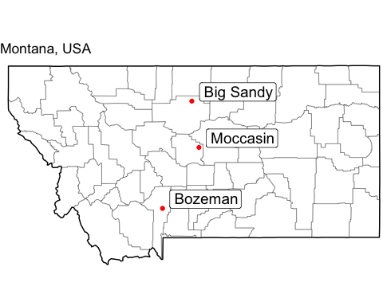

Figure 1: Location of Montana, USA field sites. Controlled B. inermis infestation site was in Bozeman, while field sites were located in centrally location Moccasin, MT and northern Big Sandy, MT.

### Figure 2

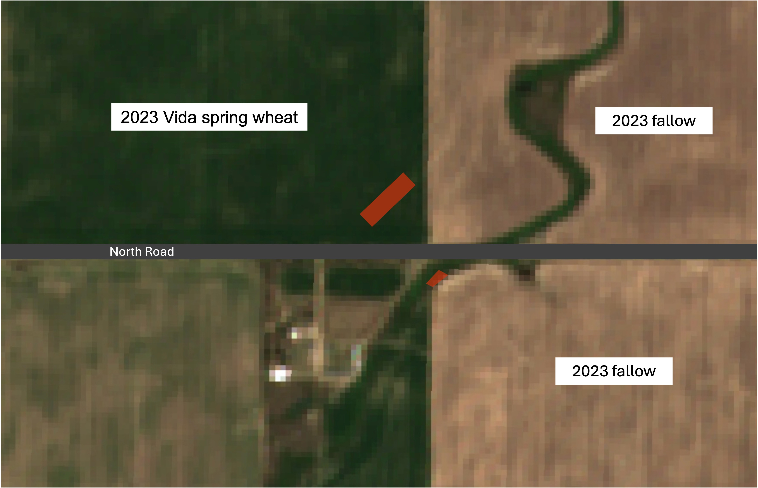

Figure 2: June 29, 2023 - Big Sandy, MT. Orange polygons denote location where NDVI was pulled using Google Earth Engine from both (upper left) Vida spring wheat and (central) coulee containing semi-natural grasses including majority B. inermis.

### Figure 3

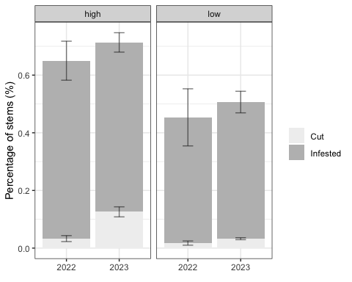

Figure 3: Comparison of year and treatment group for controlled infestation of B. inermis. Three treatment groups - high, low, and control (0) - were used. The controlled groups showed no sign of C. cinctus stem damage. We observed a significant difference in cutting between high and low treatment groups (r = 0.592, P < 0.05).

### Figure 4

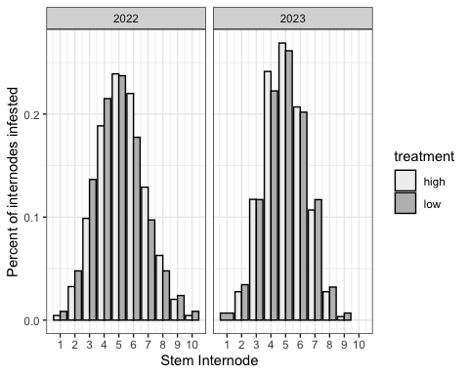

Figure 4: Ineternodes infested by B. cephi within controlled infestation plots in Bozeman, MT, USA. We found that 61.2% of stems exhibited infestation in at least 5 nodes

### Figure 5

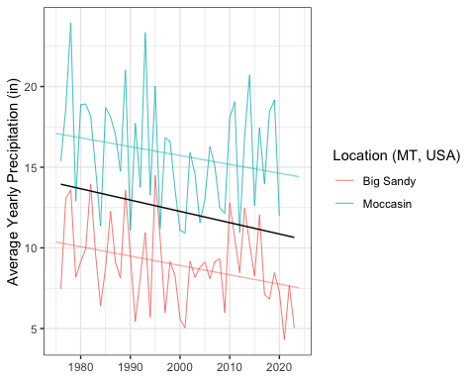 ### Figure 6 {#figure6} 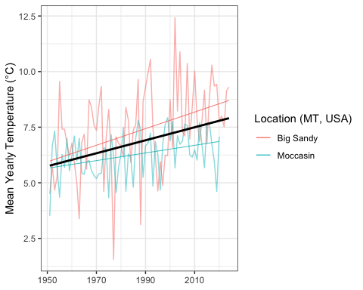

### Figure 7

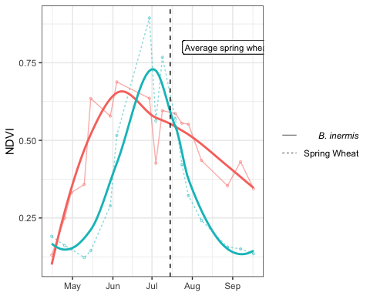

Figure 7: Normalized difference vegetation index (NDVI) of B. inermis and adjacent spring wheat field from April 2023 to October 2023 in Big Sandy, MT. Post harvest linear model indicates a significant difference (P values and stuff) when comparing the B. inermis post-harvest slope and the spring wheat post-harvest slope.

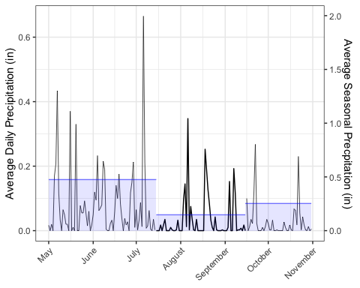

Figure 5: Average precipitation in Big Sandy, MT. Average daily precipitation

### Figure 8

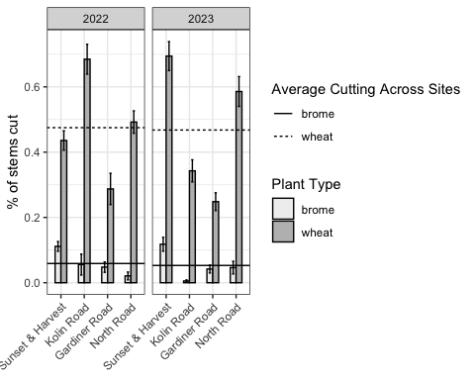 ### Figure 9 {#figure9} 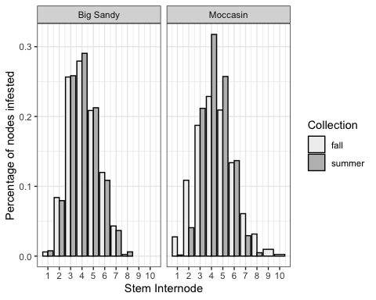

### Figure 10

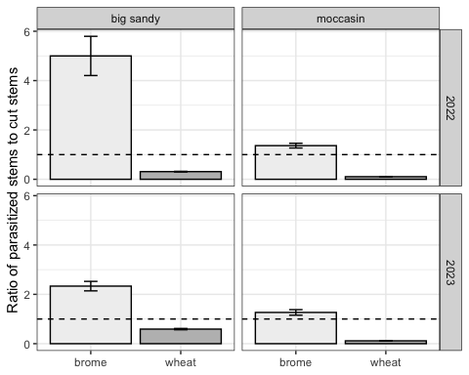

Ratios of parasitized:cut stems in B. inermis and adjacent cultivated wheat. Dotted line represents where a 1:1 cut:parasitized ratio lies.

### Figure 9

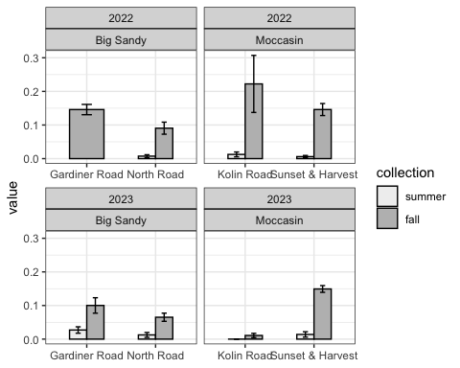

Comparison of parasitoid presence in B. inermis between July and September collections.

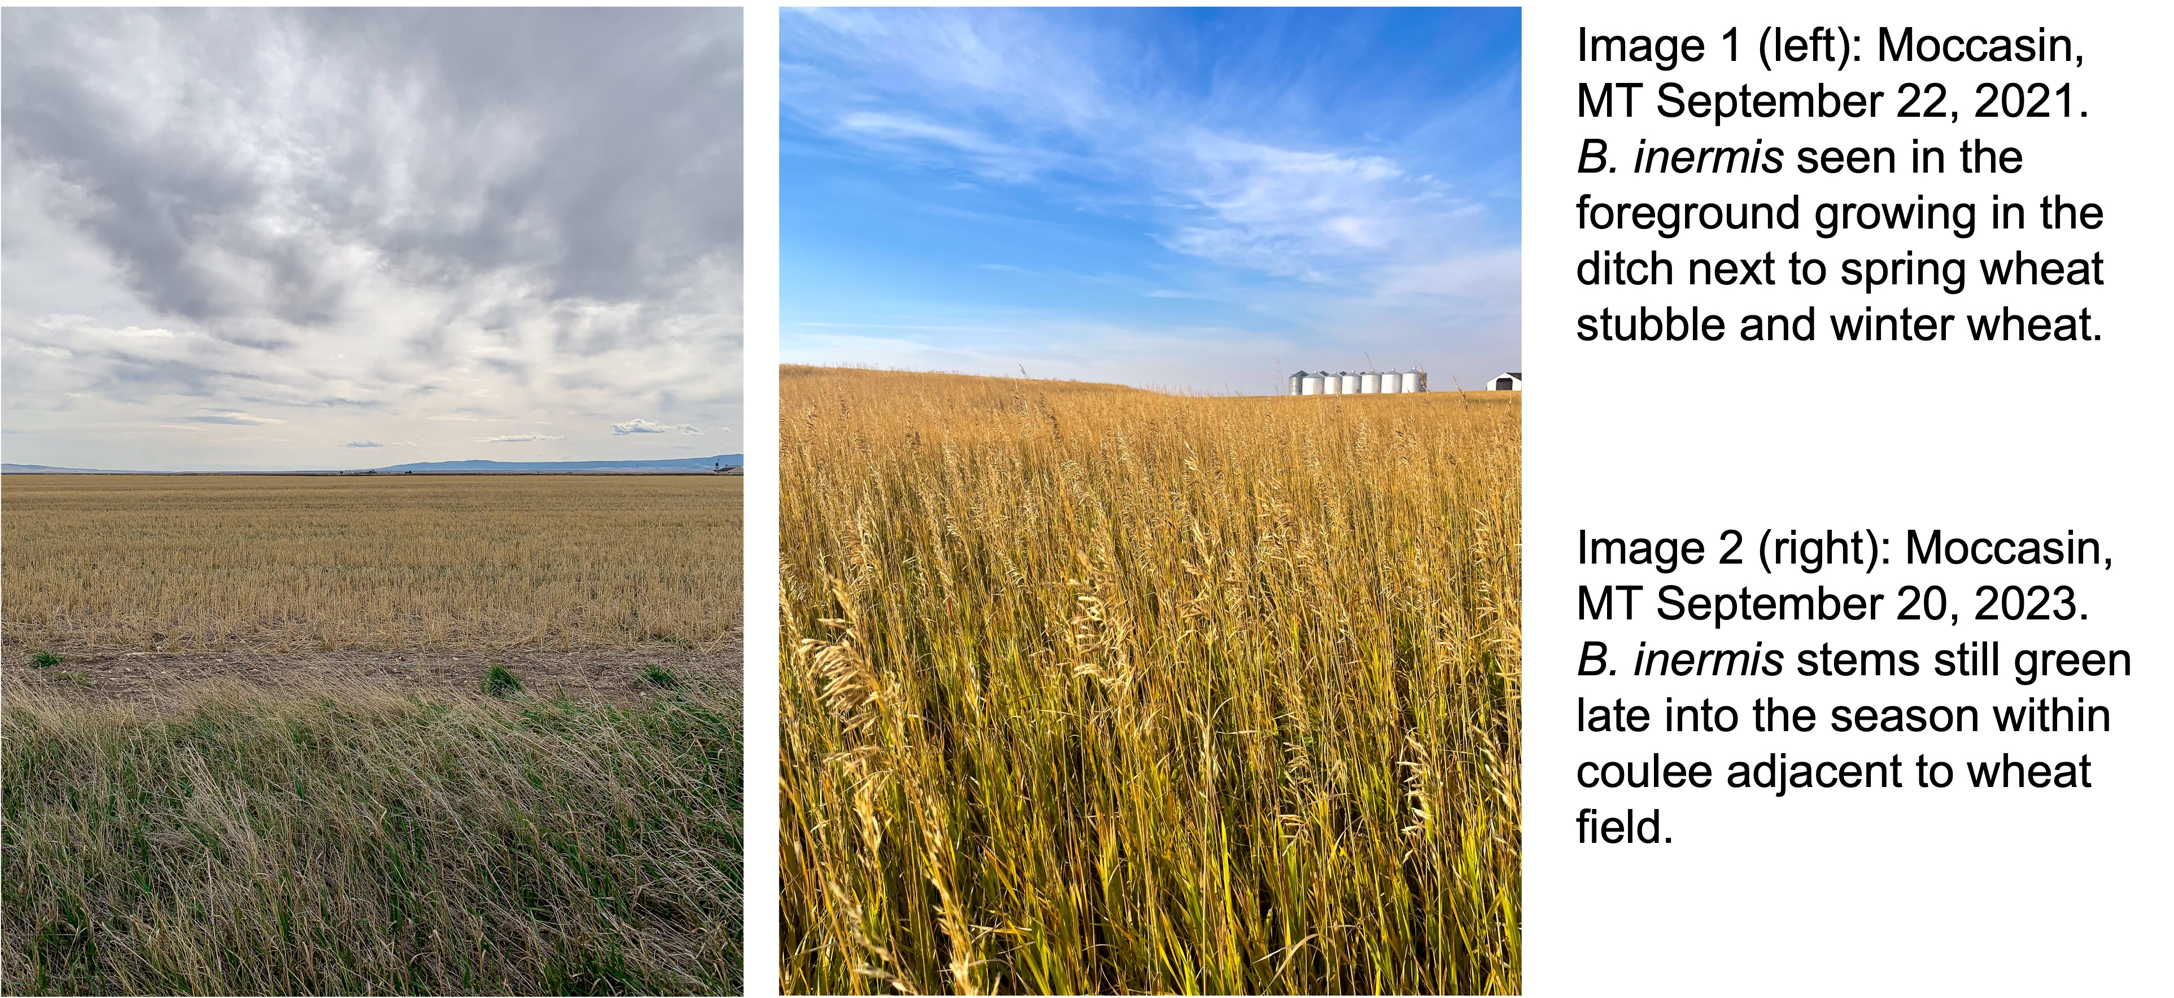 ## Citations

Achhami BB, Reddy GVP, Sherman JD, et al. 2020. Antixenosis, antibiosis, and potential yield compensatory response in barley cultivars exposed to wheat stem sawfly (hymenoptera: Cephidae) under field conditions. Journal of Insect Science. 20:1–14. <https://doi.org/10.1093/JISESA/IEAA091>.

Adhikari S, Adhikari A, Weaver DK, et al. 2019. Impacts of agricultural management systems on biodiversity and ecosystem services in highly simplified dryland landscapes. Sustainability (Switzerland). 11. <https://doi.org/10.3390/su11113223>.

Ainslie CN. 1920. The western grass-stem sawfly. United States Department of Agriculture.

Bates MD, Bolker B, Walker S. 2015. Fitting linear mixed-effects models using lme4. Journal of Statistical Software. 67:1–48.

Bekkerman A, Weaver DK. 2018. Modeling joint dependence of managed ecosystems pests: The case of the wheat stem sawfly. Journal of Agricultural and Resource Economics. 43:172–194.

Beres BL, Cárcamo HA, Weaver DK, et al. 2011. Integrating the building blocks of agronomy and biocontrol into an IPM strategy for wheat stem sawfly. Background and status. :54–65. Available from [www.prairiesoilsandcrops.caVolume4·▪2011](https://www.prairiesoilsandcrops.caVolume4·▪2011).

Beres BL, Dosdall LM, Weaver DK, et al. 2011. Biology and integrated management of wheat stem sawfly and the need for continuing research. Canadian Entomologist. 143:105–125. <https://doi.org/10.4039/n10-056>.

Bhandari R. 2020. [Assessment of host selection behaviors and oviposition preferences of cephus cinctus norton (hymenoptera: Cephidae) using wheat and smooth brome](https://www.ncbi.nlm.nih.gov/pubmed/25246403).

Buteler M, Peterson RKD, Hofland ML, et al. 2015. A multiple decrement life table reveals that host plant resistance and parasitism are major causes of mortality for the wheat stem sawfly. Environmental Entomology. 44:1571–1580. <https://doi.org/10.1093/ee/nvv128>.

Buteler M, Weaver DK, Miller PR. 2008. Wheat stem sawfly-infested plants benefit from parasitism of the herbivorous larvae. Agricultural and Forest Entomology. 10:347–354. <https://doi.org/10.1111/j.1461-9563.2008.00396.x>.

Buteler M, Weaver DK, Peterson RKD. 2009. Oviposition behavior of the wheat stem sawfly when encountering plants infested with cryptic conspecifics. Journal of Environmental Entomology. 38:1707–1715. Available from <https://academic.oup.com/ee/article/38/6/1707/361666>.

Cano D, Martínez-Núñez C, Pérez AJ, et al. 2022. Small floral patches are resistant reservoirs of wild floral visitor insects and the pollination service in agricultural landscapes. Biological Conservation. 276. <https://doi.org/10.1016/j.biocon.2022.109789>.

Carlson IT, Newell LC. 1985. Smooth bromegrass. In: Forages: the science of grassland agriculture. Iowa State University. p. 198–206. Available from <https://www.cabdirect.org/cabdirect/abstract/19850777665>.

Cockrell DM, Griffin-Nolan RJ, Rand TA, et al. 2017. Host plants of the wheat stem sawfly (hymenoptera: cephidae). Environmental Entomology. 46:847–854. <https://doi.org/10.1093/ee/nvx104>.

Cockrell DM, Randolph T, Peirce E, et al. 2021. Survey of wheat stem sawfly (hymenoptera: Cephidae) infesting wheat in eastern colorado. Journal of Economic Entomology. 114:998–1004. <https://doi.org/10.1093/JEE/TOAB015>.

Company TW. 2024. WeatherUnderground - historical weather data.

Criddle N. 1922. The western-stem sawfly and its control. Canadian Department of Agriculture.

Criddle N. 1923. Popular and practical entomology: The life habits of cephus cinctus nort. In manitoba. The Canadian Entomologist. 55:1–4.

Davis EG, Benton C, Somsen HW. 1955. Natural enemies of the wheat stem sawfly in north dakota and montana. North Dakota Agricultural Experimental Bimonthly Bulletin. 18:63–65.

Davis RA. 2013. Mechanisms for reproductive isolation in two congeneric parasitoids of the wheat stem sawfly.

Dillemuth FP, Rietschier EA, Cronin JT. 2008. Patch dynamics of a native grass in relation to the spread of invasive smooth brome (bromus inermis). Biological Invasions 2008 11:6. 11:1381–1391. <https://doi.org/10.1007/S10530-008-9346-7>.

Evans EW. 1999. Intra versus interspecific interactions of ladybeetles (coleoptera: Coccinellidae) attacking aphids.

Farstad CW, Jacobson L. 1945. Manual for sawfly control workers in alberta.

Gahan AB. 1918. Description of a new hymenopterous parasite (braconidae). In: Proceedings of the Entomological Society of Washington. Vol. 20. p. 18–19.

Hager MS, Hofland ML, Varella AC, et al. 2024. Untargeted metabolomics profiling of oat (avena sativa l.) and wheat (triticum aestivum l.) infested with wheat stem sawfly (cephus cinctus norton) reveals differences associated with plant defense and insect nutrition. Frontiers in Plant Science. 15. <https://doi.org/10.3389/fpls.2024.1327390>.

Holmes ND. 1982. Population dynamics of the wheat stem sawfly. The Canadian Entomologist. 114:775–788. <https://doi.org/10.4039/Ent114775-9>.

Holmes ND, Farstad CW. 1956. Effects of field exposure on immature stages of the wheat stem sawfly, cephus cinctus nort. (Hymenoptera: cephidae). Canadian Journal of Agricultural Science. 36:196–202. Available from <https://cdnsciencepub.com/doi/abs/10.4141/agsci-1956-0023>.

Holmes ND, Nelson WA, Peterson LK, et al. 1963. Causes of variation in effectiveness of bracon cephi (gahan) (hymenoptera: Braconidae) as a parasite of the wheat stem sawfly. The Canadian Entomologist. 95:113–126.

Holmes ND, Peterson LK. 1960. THE INFLUENCE OF THE HOST ON OVIPOSITION BY THE WHEAT STEM SAWFLY, CEPHUS CINCTUS NORT. (HYMENOPTERA: CEPHIDAE). Canadian Journal of Plant Science. 40:29–46. <https://doi.org/10.4141/cjps60-004>.

Kennedy GG, Storer NP. 2000. Life systems of polyphagous arthropod pests in temporally unstable cropping systems. Annual Review of Entomology. 45:467–493.

Lesieur V, Martin JF, Weaver DK, et al. 2016. Phylogeography of the wheat stem sawfly, cephus cinctus norton (hymenoptera: Cephidae): Implications for pest management. PLoS ONE. 11:168370. <https://doi.org/10.1371/journal.pone.0168370>.

McCullough CT, Hein GL, Bradshaw JD. 2020. Phenology and dispersal of the wheat stem sawfly (hymenoptera: Cephidae) into winter wheat fields in nebraska. Journal of Economic Entomology. 113:1831–1838. <https://doi.org/10.1093/jee/toaa093>.

Morais RMD, Freitas De Morais A de, Handte VG, et al. 2023. Enhancing arthropod communities through plant diversified edge of kale cultivation. Pesquisa Agropecuária Gaúcha. 29:77–91. <https://doi.org/10.36812/pag.202329177-91>.

Morrill WL, Kushnak GD. 1996. Wheat stem sawfly (hymenoptera: Cephidae) adaptation to winter wheat. Environmental Entomology. 25:1128–1132. <https://doi.org/10.1093/EE/25.5.1128>.

Morrill WL, Kushnak GD, Gabor JW. 1998. Parasitism of the wheat stem sawfly (hymenoptera: Cephidae) in montana. Biological Control. 12:159–163. <https://doi.org/10.1006/bcon.1998.0629>.

Morrill WL, Weaver DK, Johnson GD. 2001. Trap strip and field border modification for management of the wheat stem sawfly (hymenoptera: cephidae). Journal of Entomological Science. 36:34–45. <https://doi.org/10.18474/0749-8004-36.1.34>.

Nansen C, Macedo TB, Weaver DK, et al. 2005. Spatiotemporal distributions of wheat stem sawfly eggs and larvae in dryland wheat fields. Canadian Entomologist. 137:428–440. <https://doi.org/10.4039/n04-094>.

Nelson WA, Farstad CW. 1953. Biology of bracon cephi (gahan) (hymenoptera: Braconidae), an important native parasite of the wheat stem sawfly, cephus cinctus nort. (Hymenoptera: Cephidae), in western canada. The Canadian Entomologist. 85:103–107. <https://doi.org/10.4039/Ent85103-3>.

Olfert O, Weiss RM, Catton H, et al. 2019. Bioclimatic assessment of abiotic factors affecting relative abundance and distribution of wheat stem sawfly (hymenoptera: Cephidae) in western canada. Canadian Entomologist. 151:16–33. <https://doi.org/10.4039/tce.2018.46>.

Otfinowski R, Kenkel NC, Catling PM. 2006. The biology of canadian weeds. 134. Bromus inermis leyss. Canadian Journal of Plant Science. 87:183–198.

Pederson GT, Graumlich LJ, Fagre DB, et al. 2009. A century of climate and ecosystem change in western montana: What do temperature trends portend? Climatic Change. 98:133–154. <https://doi.org/10.1007/s10584-009-9642-y>.

Peirce ES, Rand TA, Cockrell DM, et al. 2021. Effects of landscape composition on wheat stem sawfly (hymenoptera: Cephidae) and its associated braconid parasitoids. Journal of Economic Entomology. 114:72–81. <https://doi.org/10.1093/jee/toaa287>.

Perez-Mendoza J, Weaver DK. 2006. Temperature and relative humidity effects on postdiapause larval development and adult emergence in three populations of wheat stem sawfly (hymenoptera: cephidae). Environmental Entomology. 35:1222–1231. <https://doi.org/10.1093/ee/35.5.1222>.

Peterson RKD, Buteler M, Weaver DK, et al. 2011. Parasitism and the demography of wheat stem sawfly larvae, cephus cinctus. BioControl. 56:831–839. <https://doi.org/10.1007/s10526-011-9357-7>.

Peterson RO. 1999. Wolf-moose interaction on isle royale: The end of natural regulation. Ecological Applications. 9:10–16. [https://doi.org/10.1890/1051-0761(1999)009[0010:WMIOIR]2.0.CO;2](https://doi.org/10.1890/1051-0761(1999)009%5b0010:WMIOIR%5d2.0.CO;2).

Pettorelli N, Vik JO, Mysterud A, et al. 2005. Using the satellite-derived NDVI to assess ecological responses to environmental change. Trends in Ecology and Evolution. 20:503–510. <https://doi.org/10.1016/j.tree.2005.05.011>.

Rand TA, Kula RR, Gaskin JF. 2024. Evaluating the use of common grasses by the wheat stem sawfly (hymenoptera: Cephidae) and its native parasitoids in rangeland and conservation reserve program grasslands. Liu T-X, editor. Journal of Economic Entomology. <https://doi.org/10.1093/jee/toae046>.

Rand TA, Richmond CE, Dougherty ET. 2020. Modeling the combined impacts of host plant resistance and biological control on the population dynamics of a major pest of wheat. Pest Management Science. 76:2818–2828. <https://doi.org/10.1002/ps.5830>.

Runyon JB. 2001. Wheat stem sawfly parasitism in varying field sizes and tillage systems in dryland wheat in montana. Canadian Entomologist. 133.

Runyon JB, Hurley RL, Morrill WL, et al. 2001. Distinguishing adults of bracon cephi and bracon lissogaster (hymenoptera: Braconidae), parasitoids of the wheat stem sawfly (hymenoptera: cephidae). Canadian Entomologist. 133:215–217. <https://doi.org/10.4039/Ent133215-2>.

Runyon JB, Morrill WL, Weaver DK, et al. 2002. Parasitism of the wheat stem sawfly (hymenoptera: Cephidae) by bracon cephi and b. Lissogaster (hymenoptera: Braconidae) in wheat fields bordering tilled and untilled fallow in montana. Journal of economic entomology. 95:1130–1134. <https://doi.org/10.1603/0022-0493-95.6.1130>.

Salesman JB, Thomsen M. 2011. Smooth brome (bromus inermis) in tallgrass prairies: A review of control methods and future research directions. Ecological Restoration. 29:374–381. <https://doi.org/10.3368/er.29.4.374>.

Seamans HL. 1928. The value of trap crops in the control of the wheat stem sawfly in alberta. The Value of Trap Crops in the Control of the Wheat Stem Sawfly in Alberta.

Shanower TG, Hoelmer KA. 2004. Biological control of wheat stem sawflies: Past and future. Journal of Agricultural Entomology. 21:197–221.

Somsen HW, Luginbill P. 1956. Bracon lissogaster mues: A parasite of the wheat stem sawfly. USDA Technical Bullitin. 1153. Available from <https://www.google.com/books/edition/Bracon_Lissogaster_Mues/37UXAAAAYAAJ?hl=en&gbpv=1&dq=Bracon+Lissogaster+Mues:+A+Parasite+of+the+Wheat+Stem+Sawfly.&pg=PA29&printsec=frontcover>.

Team RC. 2024. R: A language and environment for statistical computing.

Tscharntke T, Karp DS, Chaplin-Kramer R, et al. 2016. When natural habitat fails to enhance biological pest control – five hypotheses. Biological Conservation. 204:449–458. <https://doi.org/10.1016/j.biocon.2016.10.001>.

Villacorta A, Bell R, Callenbach J. 1971. Influence of high temperature and light on postdiapause development of the wheat stem sawfly. Journal of Economic Entomology. 64:749–751.

Wallace LE, McNeal FH. 1966. Stem sawflies of economic importance in grain crops in the united states. U.S. Department of Agriculture Technical Bulletin No. 1350. Available from <https://books.google.com/books?hl=en&lr=&id=dcMXAAAAYAAJ&oi=fnd&pg=PA1&dq=Stem+sawflies+of+economic+importance+in+grain+crops+in+the+United+States&ots=e0FbKZOb6x&sig=_fPd1FCRZ_HK-Ncv2POX-EFMvOo#v=onepage&q=Stem sawflies of economic importance in grain cro>.

Weaver D. 2023. Wheat stem sawfly (cephus cinctus norton). p. 93–134. <https://doi.org/10.19103/as.2022.0114.13>.

Weaver DK, Nansen C, Runyon JB, et al. 2005. Spatial distributions of cephus cinctus norton (hymenoptera: Cephidae) and its braconid parasitoids in montana wheat fields. Biological Control. 34:1–11. <https://doi.org/10.1016/j.biocontrol.2005.04.001>.

Wickham H. 2016. ggplot2: Elegant graphics for data analysis. Available from <https://ggplot2.tidyverse.org>.

Willson GD, Stubbendieck J. 2000. A provisional model for smooth brome management in degraded tallgrass prairie. Ecological Restoration. 18:34–38. <https://doi.org/10.3368/er.18.1.34>.

Wilson ML. 1923. Dry farming in the north central montana triangle. Bowden RB, editor.

Zhu P, Burney J. 2021. Temperature-driven harvest decisions amplify US winter wheat loss under climate warming. Global Change Biology. 27:550–562. <https://doi.org/10.1111/gcb.15427>.